“Readiness Assessment Questionnaire
My organization or unit is: _____________________________________________________________

My program area is: ___________________________________________________________________

My role is: ___________________________________________________________________________

Instructions for Completion”

“There are no “right” or “wrong” answers. For each question in this questionnaire, please circle the number from 1 to 5 that most closely reflects how you feel about the two given statements.

Please be candid in your responses, and draw on your most recent experience in the last two years.”

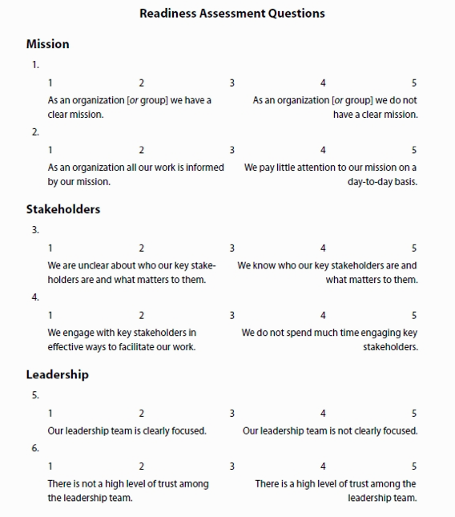
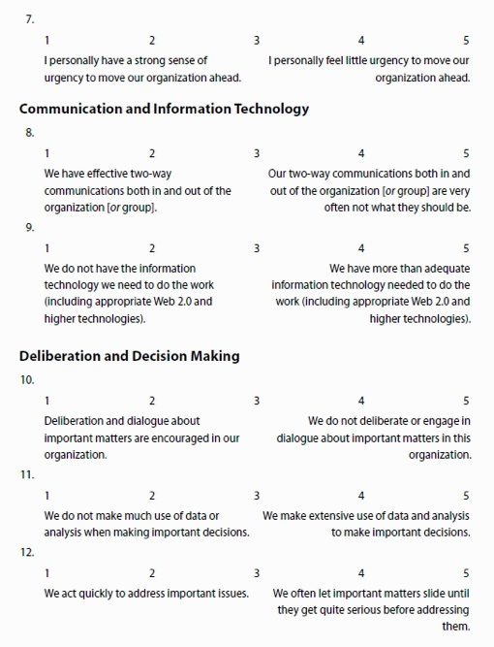
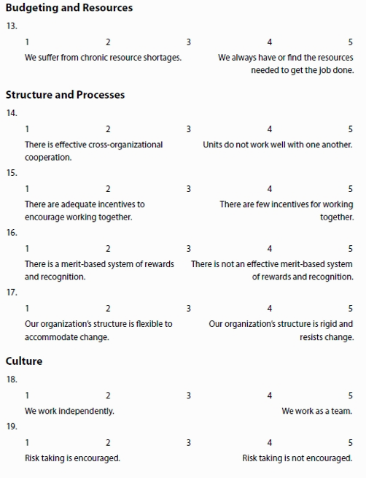
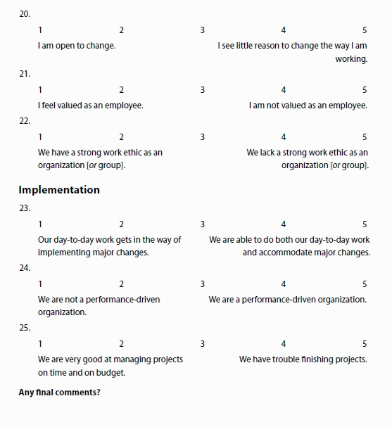

“The results of the questionnaire can be tabulated by the organization as a whole or by groups or specific stakeholders.

The average answer here might be 2.3, meaning “we often suffer from resources shortages.” Thus resource development or use may be a strategic issue that will need to be addressed; otherwise, plan implementation is likely to suffer

In this example, two groups have responded quite differently. Managers’ (Mgt) average answer is 2.2, whereas other employees’ (Emp) average answer is 3.8. These two groups thus experience the organization very differently. Managers feel more valued and other employees feel less valued. The sources of this difference need to be explored, and the findings may lead to the identification of major strategic issues and implications for the design of the strategic planning process.

In this example as well, organizational members’ (Org) average score of 2.1 indicate that they think two-way communications are far more effective than do external stakeholders (Ext), whose average score of 4.3 indicates some serious problems with externally oriented two-way communications. Again, there are likely to be some important implications for the strategic planning process and for strategic issues that need to be addressed.

Interpreting Total Scores Across All Questions

In order to come up with a total score for the organization as a whole, you will first have to reverse score several questions, so that on all scales a score of 5 indicates the organization is in very good condition with regard to the particular item. (On this survey, questions 1, 2, 4, 5, 7, 8, 10, 12, 14, 15, 16, 17, 19, 20, 21, and 25 need to be reverse scored.)

Once the reverse scoring is complete, add up all the scores. There are twenty-five questions, so the highest possible score is 125.”

“Total Score | Total Score
101–125 | The organization is generally in very good shape and probably just needs some fine-tuning to address some specific issues. Alternatively, the organization may be poised to pursue a full-blown effort to go to the next level.
75–100 | The organization has some significant issues that are keeping it from fulfilling its full potential. Any really serious issues should be the focus of a targeted strategic planning effort to address them. These issues might be addressed as part of a larger overall strategic planning effort, but they may well need to be addressed first.
50–74 | The organization faces very serious issues. Scores indicate either mediocrity across the board or else some specific issues meriting serious attention. If the organization is to survive, a concerted effort will be needed to address these issues. Organizational transformation of some sort is needed (perhaps over a significant time period) and will require impressive leadership efforts to achieve. Decide whether the leadership group (broadly defined) is up to the effort, the leadership group is in need of development, or new leadership is required.
25–49 | “The organization is in trouble. The scores indicate either barely adequate performance across the board or some possible areas of strength but other major areas in need of drastic improvement. Consider addressing the most important of these issues prior to engaging in a full-blown strategic planning effort. Strong leadership of many kinds will be needed if the organization is to change enough to ensure survival.”
0-24 | The organization is in quite serious trouble. A slow (or not so slow) death is under way and may be hastened by any significant shock. Try to fix one or a few of the serious issues to assess whether it is worth the effort to try to revive the organization.”  Fragmento de: John M. Bryson. “Creating and Implementing Your Strategic Plan: A Workbook for Public and Nonprofit Organizations”. Apple Books.

The interpretation of a readiness survey illuminates an important paradox of strategic planning: it is least needed where it is most likely to work—that is, in organizations that score in the upper part of the possible range—and most needed where it is least likely to work—that is, in organizations that score in the lower part of the range. More explicitly, organizations with low scores are unlikely to have the leadership and resources necessary to address the many issues they face, so the chances that everything will come together in an adequate way for them are not high (Bryson, 2011). Nonetheless, the authors of this workbook have seen dramatic turnarounds, so success, even though hardly assured, is not out of the question.

Questionnaire adapted from proprietary materials developed by Farnum Alston and The Crescent Company, Bozeman, Montana”

